LAB 1:

21K-4540

Q1:

1. Create the file1.txt and file2.txt using cat command and then create file3.txt which have merged the content of file1.txt and file2.txt. after creating file3.txt rename it to final.txt

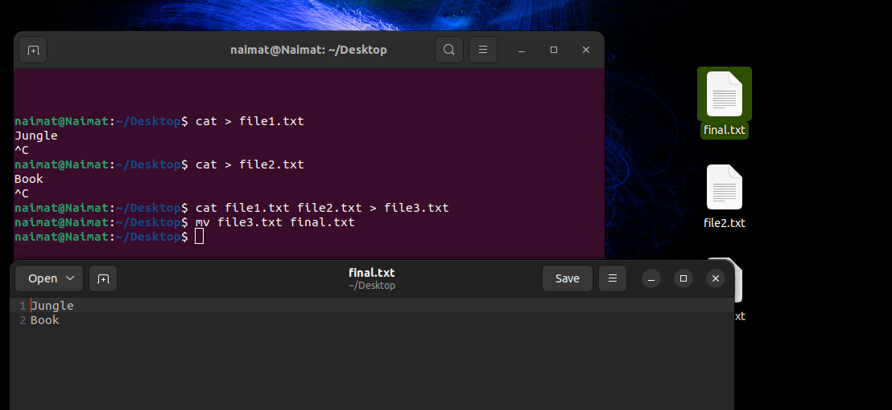

Q2:

1. Perform The following
2. Create folder1 and folder2 in Desktop
3. Create first.txt and second.txt in Desktop
4. Now copy the first.txt in folder1 and cut the second.txt inside folder2

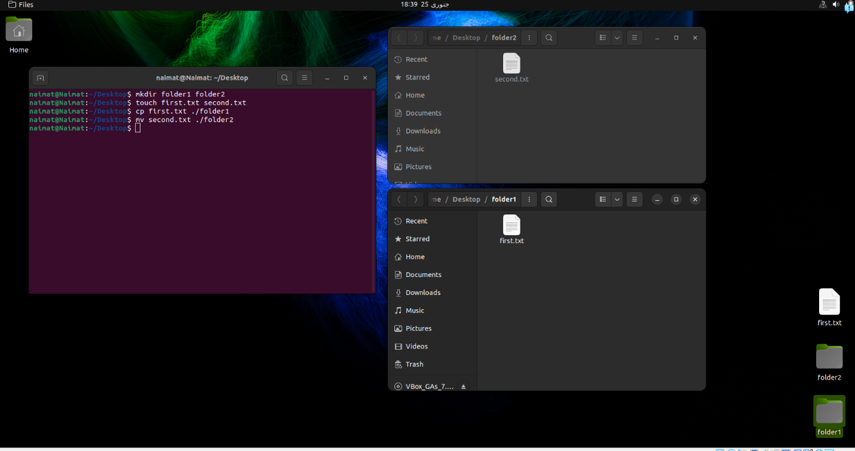

Q3:

1. Perform the following
2. Make an alias for exit
3. Use that alias to exit the terminal
4. Open the terminal again make alias for exit again and then delete it

Part a , b:



Part c:



Q4:

1. Use find command to search for files that have “.txt” file extension

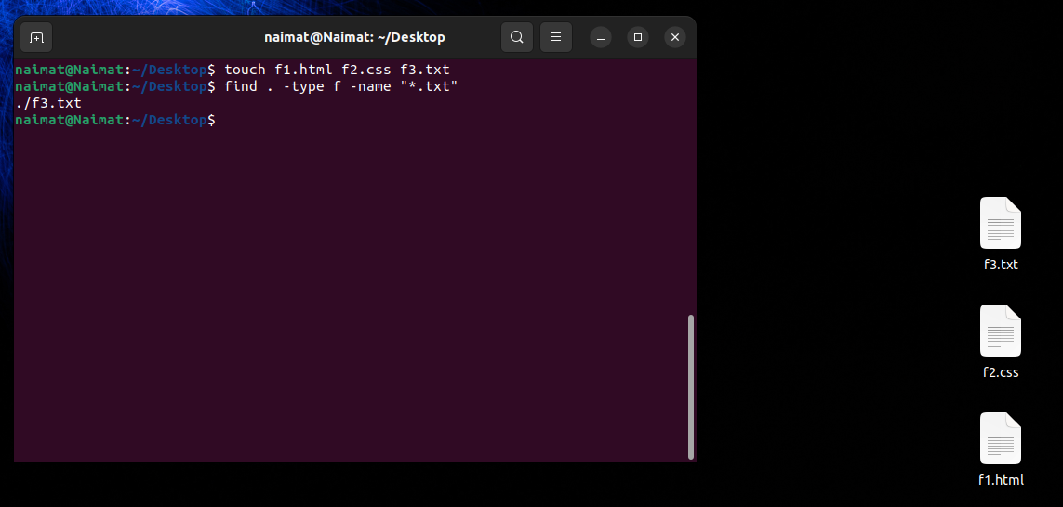

Q5:

1. Crete a folder name task5 on desktop add 2 text files and 3 html files and then make a compressed file of all those 5 tasks

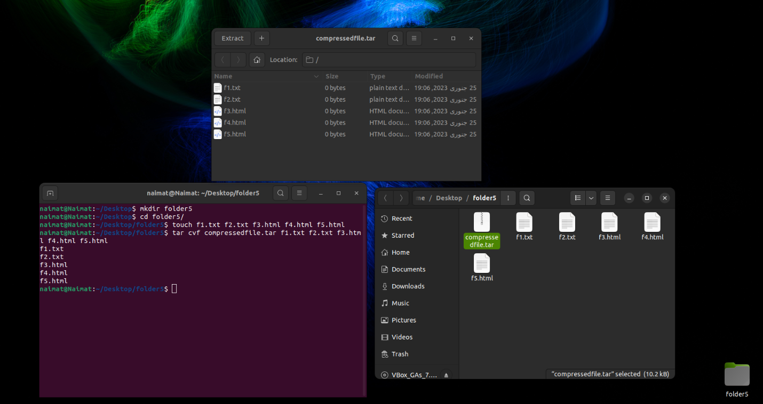

Q6:

1. Use a Linux command to list all the processes and count total

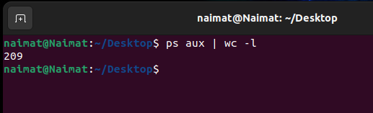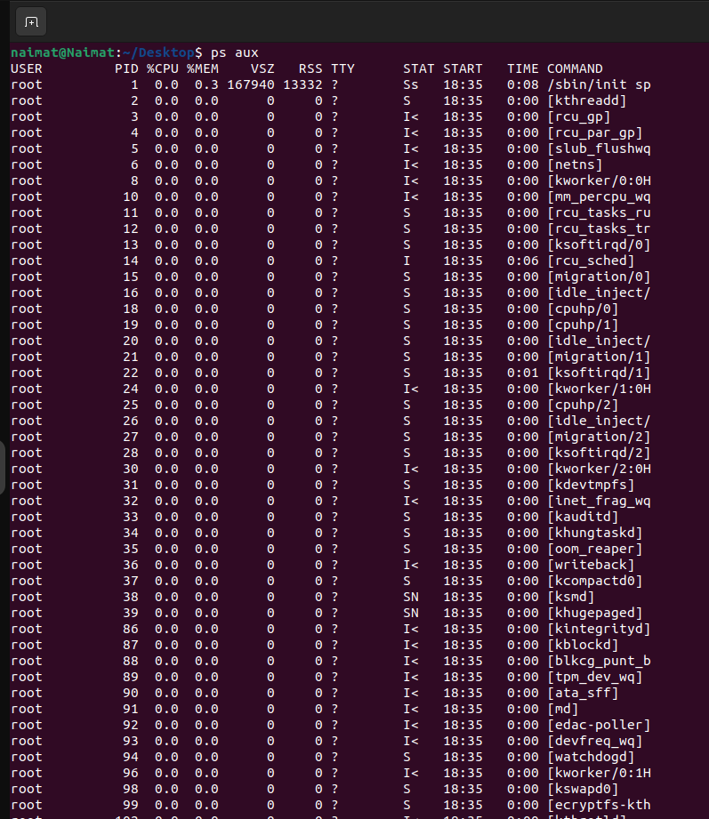

Q7:

1. List out the previous 40 command being run previously on terminal

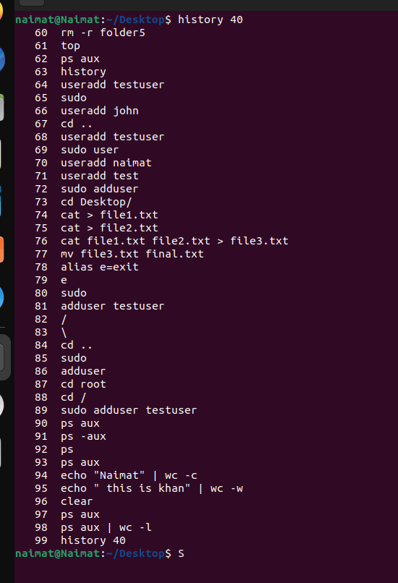

Q8:

1. Add the new user with name **test user** and set the password as test1234. After adding test login, the test user

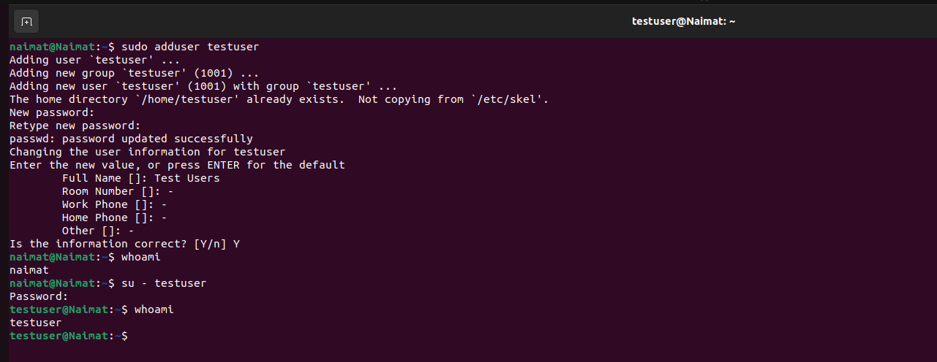

Q9:

Delete the test *user and check if the user is deleted or not*

